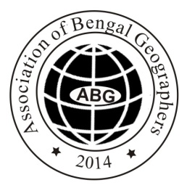

XIV INTERNATIONAL GEOGRAPHICAL UNION (IGU)-INDIA International Conference under the auspices of five IGU Commissions: Commission on Biogeography and Biodiversity, Commission on Land Use and Land Cover Change, Commission on Hazard and Risk, Commission on Climatology, and Commission on Geo-Heritage was held during 6-8 March 2020. The focal theme of the conference was “Agriculture, Food, Water, Biodiversity and Health in Changing Climate”. This mega conference was organized by the Department of Geography, The University of Burdwan, West Bengal, India in collaboration with Association of Bengal Geographers.
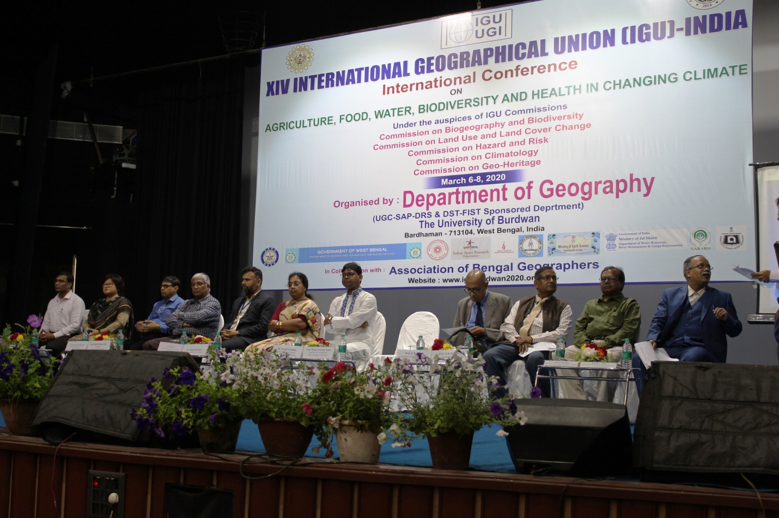
Dignitaries present on the dais in the Inaugural Session of XIV IGU-INDIA International Conference
Inaugural Session
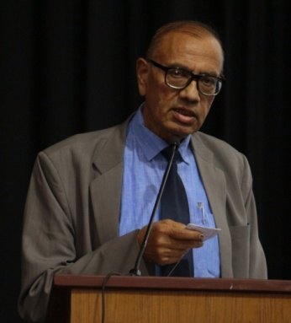
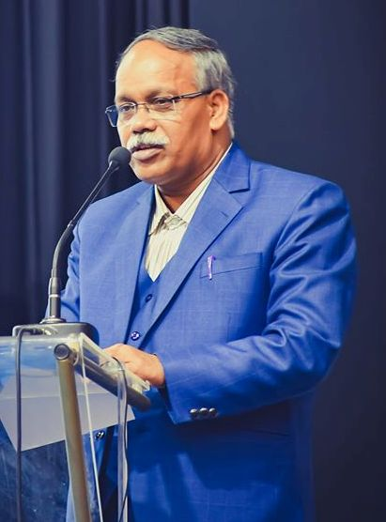
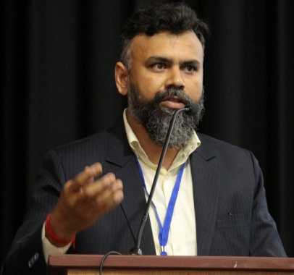
Inaugural function of XIV IGU-INDIA International Conference was held in the Central Auditorium of the University of Burdwan at Golapbag Campus on 6th March 2020. In the inaugural session, the dignitaries present on the dais were Mr. Shyamal Santra, Hon’ble Minister-of-state in charge of Public Health Engineering & Panchayats & Rural Development, Government of West Bengal, Prof. R. B. Singh, Secretary General & Treasurer, International Geographical Union; Dr. Tapati Banerjee, Director, National Atlas & Thematic Mapping Organisation, Government of India; Prof. Abhijit Mazumdar, Registrar, Prof. Pabitra Kumar Chakraborti, Dean, Faculty Council of Science, The University of Burdwan; Prof. Jayant K. Routray, Professor Emeritus, Asian Institute Technology, Thailand; Dr. Suraj Mal, Chair: IGU Commission on Biogeography and Biodiversity; Prof. N. C. Jana, Convener, Prof. Giyasuddin Siddique, President, Dr. Biswaranjan Mistri, Organizing Secretary of this conference, and Dr. Namita Chakma, Head of the Department of Geography.
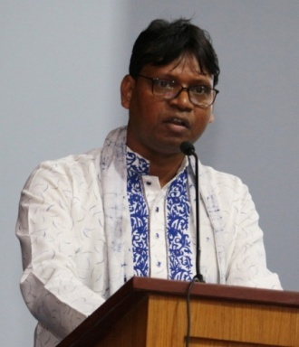
Mr. Shyamal Santra Prof. R. B. Singh Prof. N. C. Jana Dr. Suraj Mal

Plenary Sessions
Three Plenary Sessions were organized during 6-8 March. On 6th March, Plenary Session-I: Disaster Risk Reduction and Resilience in Changing Climate was organized. The renowned speakers were Prof. R. B. Singh, Secretary General & Treasurer-IGU, Delhi University, India; Dr. Tapati Banerjee, Director, NATMO; Prof. Takashi Oguchi, University of Tokyo, Japan (video recorded lecture). Prof. Oguchi could not come because of his suspension of Visa at the last moment.
On 7th March, Plenary Session-II: Urban Health and Social Wellbeing in Changing Climate was organized. The renowned speakers delivered lectures in this session were Prof. D. K. Nayak, North Eastern Hill University, Shillong, India; Prof. Anuradha Banerjee, Jawaharlal Nehru University, New Delhi, India; Prof. Ravi S Singh, Banaras Hindu University, Varanasi, India; Prof. Bimal Kar, Gauhati University, Guwahati, India; and Prof. V. Nagarale, SNDT Women University, Pune, India
In the Plenary Session-III: Sustainable Development Goals and Future Earth Initiatives on 8th March, the renowned speakers were Prof. J. K. Routray, Asian Institute Technology, Thailand; Prof. Sahab Fazal, Aligarh Muslim University, India; and Prof. Nandini Chakravarty Singh, Rajiv Gandhi University, India

Special Lecture Sessions
Special Lecture Sessions were organized in the last two days of the conference. The speakers were Prof. Kazuo Tomozawa, Hiroshima University, Japan; Dr. Sandeep Narayan Kundu, NUS, Singapore; Dr. Amitanshu Pattanaik, DTRL, Defense Research Development Organization, Delhi, India; and Dr. Komali Yennetti, Chair: IGU-YECG, Australia. Prof. Tomozawa and Dr. Kundu could not come because of their suspension of Visa due to COVID-19 Pandemic but the video recorded lecture of Dr. S. N. Kundu was displayed.
Late Dr. Manju Singh Memorial Young Scientist Best Paper Award 2020
On 8th March, open competition was held in the University Auditorium. 09 Research Scholars appeared in this competition for this prestigious award. This competition was organized under the auspices of International Geographical Union Taskforce for Young and Early Career Geographers under the leadership of Dr. Komali Yennetti, Chair and Dr. Gaurav Sikka, Secretary General. A Panel of Judges selects Sri Soumen Ghosh of the Department of Geography, The University of Burdwan, for this award.

Training on Snow Cover Dynamics and Glacier Fluctuations in the Himalaya
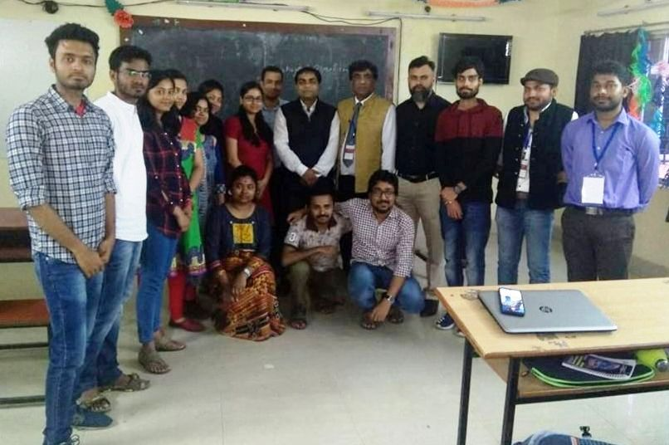
In the venue of XIV IGU-INDIA International Conference, Two-days software training on Snow Cover Dynamics and Glacier Fluctuations in the Himalaya were organized during 7-8 March 2020, supported by IGU Commission on Biogeography and Biodiversity. Prof. R. B. Singh introduced the programme. Dr. Suraj Mal and Dr. Pankaj Kumar of Delhi University conducted the training programme. 14 candidates participated in this training programme.
Dr. Suraj Mal and Dr. Pankaj Kumar (Trainer) with the participants of Training Programme

Technical Sessions
436 abstracts had been received and nearly 400 participants presented their papers in 38 parallel technical sessions under the sub-themes: (i) Agricultural Development, Forestry and Biodiversity; (ii) Development and Sustainability; (iii) Ecosystem Management, Monitoring and Modelling; (iv) Environment, Human Health & Well-being; (v) Globalization, Industrialization and Environmental Issues; (vi) Land Use Land Cover and Climate Change; (vii) Land Use Land Cover Change and Biodiversity; (viii) Population Pressure, Natural Resource Use and Climate Change; (ix) Role of GIS Technology; (x) Sustainable Natural Resource Management and Development; (xi) Tourism Potential of Geo-Heritage Sites in South Asia; (xii) Urbanization and Environmental Issues; and (xiii) Water Resource Management.

Valedictory Session
On 3rd day of the conference Valedictory Session was held in the Conference Hall of the Department of Geography. Prof. R. B. Singh; Prof. L. N. Satpati, Director-HRDC, University of Calcutta; Prof. N. C. Jana and Prof. Giyasuddin Siddique and a number renowned Geographers and Scientists were present. Some of them highly appreciated the organizers for organizing such a high quality smart conference.

Acknowledgements
This historical mega event could not have been possible without the support from sponsoring agencies. The organizers have received financial assistance from the Ministry of Water Resources, Government of India; Defence Research and Development Organisation, Government of India; Indian Council of Social Science Research, New Delhi; Anthropological Survey of India, Kolkata; National Atlas &Thematic Mapping Organisation, Government of India; Department of Science & Technology, Government of West Bengal; IGU Commission on Biogeography and Biodiversity; National Bank for Agricultural and Rural Development (NABARD), Government of India.

Report prepared by
Prof NC Jana
University of Burdwan

