9th India International Geographical Union (IGU) Conference, New Delhi,
(18-20 March, 2016)

Conference Report and Contribution

The Department of Geography, Shaheed Bhagat Singh College, University of Delhi, New Delhi organised the 9th India International Geographical Union (IGU) conference on Land Use Change, Climate Extremes and Disaster Risk Reduction on March 18-20 March 2016. Four of the IGU Commissions – Commission on Biogeography and Biodiversity, Commission on Land Use and Land Cover Change, Commission on Hazards and Risk, Commission on Geopark –collaborated in this conference. A total of 35 oral presentation sessions and 2 poster sessions were organized. Besides, more than 40 international delegates (including IGU Executive members) from about 20 countries and more than 350 Indian delegates representing 27 states and UTs attended the conference. The conference had the representation of major science and research academies of India and abroad, including 1) International Geographical Union (IGU), 2) International Union of Geodesy and Geophysics (IUGG), 3) International Academic Partnership (IAP) - Global Network of Science Academies, 4) Commonwealth Scientific and Industrial Research Organization (CSIRO-Australia), 5) Chinese of Academy of Sciences, 6) Polish Academy of Sciences, 7) Russian Academy of Sciences, 8) National Geophysical Research Institute, Hyderabad, 9) Indian National Science Academy, 10) Defense Research and Development Organization and 11) Geological Survey of India etc.

The dignitaries for the inaugural session were Dr. Krishan Lal, Co-Chair, International Academic Partnership (IAP) - Global Network of Science Academies and Ex-President, Indian National Science Academy (INSA) as Chief Guest; Dr. Harsh Gupta, President, Geological Society of India and Ex-President, IUGG; Prof. Vladimir Kolossov, President, IGU; Prof. R.B. Singh, Vice-President, IGU as Guest of Honor and Prof Tom Beer, Ex IGU President as Keynote Speaker; Dr. P.K. Khurana, Patron and Dr. Suraj Mal, Convener. Dr. Krishan Lal quoting the present climate change and impending problems due to it asked for an interdisciplinary platform to mitigate these problems. Dr. Harsh Gupta in his address emphasized on role of geography in reducing the risk of disasters. Citing the examples of various earthquakes in past he asked geographers to contribute towards Disaster Risk Reduction for future sustainability. Prof. Vladimir Kolossov talking about IYGU emphasized on bridging the gap in awareness between local actions and global effects, to encourage everyone to make daily decisions in light of global challenges and to contribute to bottom-up initiatives that connect individual, local action to global sustainability. Prof. Tom Beer delivered the keynote address on the Impact of Extreme Weather Events on Food Security. Prof. Beer examined the historical link between weather, food supplies, and food distribution; examine the Asian and international situation; summarise the response of the scientific community and point out the direction for future research.

Prof. RB Singh and Prof. Michael Meadows were two keynote speakers in the plenary session presided by Prof. D. Soyez, Vice-President, IGU. Prof RB Singh, delivering his address on Urban Health and Well being suggested the researchers to understand the relationship between urbanization, environmental degradation and health, and suggested that regression analysis under the systems approach is useful in identifying the major urban health challenges due to air pollution. He also focussed on various recent global initiatives like Sendai Framework of Disaster Risk Reduction, Sustainable Development Goals, UNFCC COP21, Future Earth, Habitat III and about the role geographers can perform to contribute to these initiatives.

Prof. Michael Meadows in his key note addressed the Global Environments in the Anthropocene: Challenges for Future Earth. He emphasized on need to systematically incorporate a stronger physical geography perspective into global change science; the Anthropocene represents an appropriate platform from which to inject that perspective.

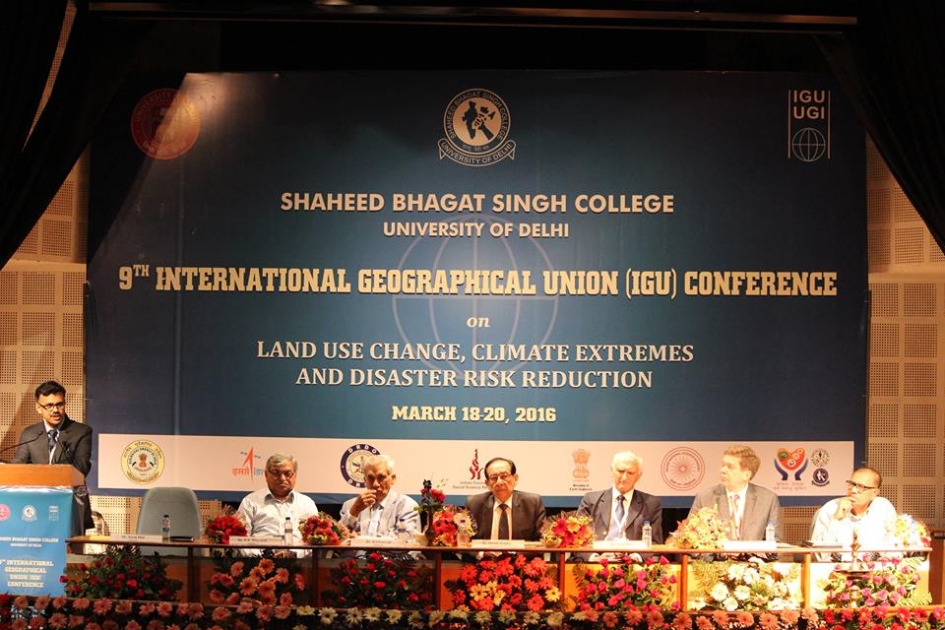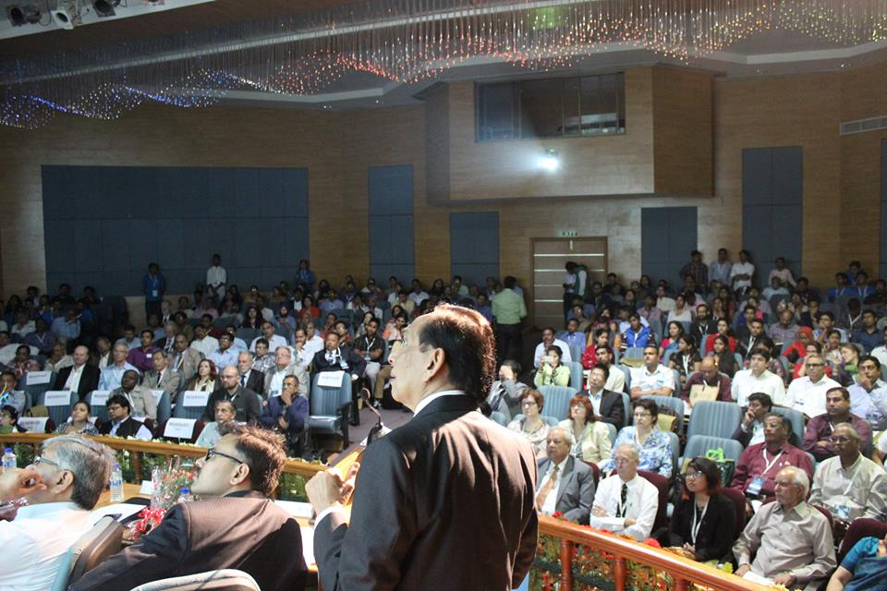
Inaugral Session Address by Dr. Harsh Gupta

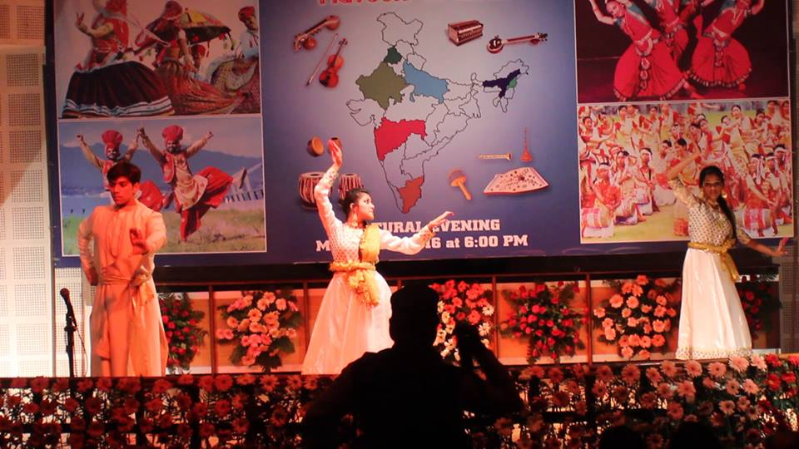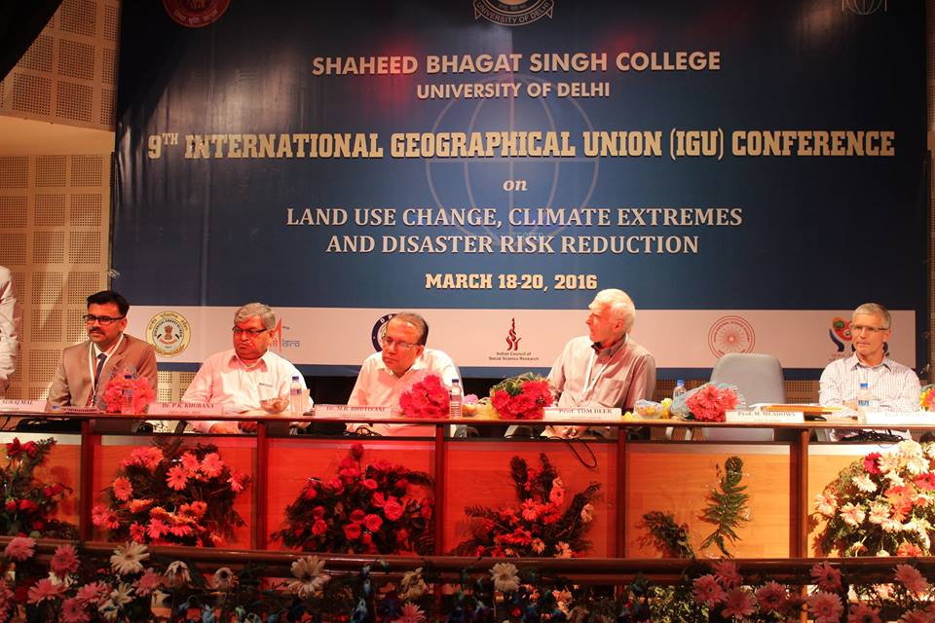
Cultural Programme Valedictory Session

Out of the total 35 oral presentation sessions, six sessions were on Land Use Land Cover Change and Climate Change, Five sessions on Human Health and Wellbeing, Four sessions on Environmental Sustainability and Developmental Concerns, Three sessions each for Resource Conservation and Management, Extreme Environment Events, Environmental Change, Two presentation each on Disaster Risk Reduction, Ecological Modelling, Governance and Policies, Land use land cover change and Biodiversity, One session each on Himalayan Environment, Challenges and Strategies to Climate Resilient Livelihoods and Geoparks Potential in South Asia. The sessions on Land use land cover change encompassed the issues of Geo-Spatial Technologies in LULC, Climate Change and LULC in Arid Ecosystems, LULC in Urban areas and LULC and Biodiversity. The sessions on Human Health and Wellbeing had presentations on Health and Diseases, Geography of Gender and Marginalised, Environmental Quality, Urban Environment and Human Development. The sessions on Environmental Sustainability and Developmental Concerns encompassed issues on Water Issues and Hydropower Projects, Environmental Concerns and Urban Sustainability. The theme of Resource Conservation and Management had paper presentation on Natural Resource based Livelihood, Water Resource Management and Land based Resources. The broad topics for presentation in the sessions of Extreme Events were Landslides, Earthquake, Urban Environment Change and Rainfall and Floods. The sessions on Disaster Risk Reduction focussed on Analysis and Assessment of Disasters and Disaster Management. Geo-Spatial Modelling, Monitoring and Management were the major themes for the sessions of Ecological Modelling. Therefore, the conference covers a wide range of research topics, which contributed to the existing knowledge and science.

The valedictory session was graced by Dr. M.R. Bhutiyani, Director, DTRL, DRDO as the Chief Guest, Prof. Iain Hay, Vice-President IGU and Prof. R.B. Singh, Vice-President, IGU as Guest of Honor and Presided by Prof. Tom Beer. Dr. Bhutiyani citing the examples from Himalaya emphasized on promoting research on Climate Change and Himalayan Glaciers as the sustainability of low land depends on the sustainability of highlands. Prof. Iain Hay emphasized on the need of geographical education as a solution to various global problems.

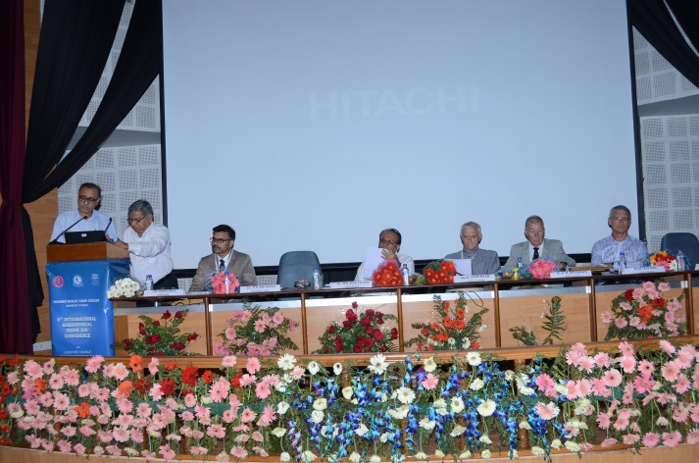
Prof RB Singh and Dr PK Khurana announcing Delhi Declaration, 20 March, 2016

We acknowledge the financial support of funding agencies, particularly the Indian Council of Social Science Research (ICSSR), New Delhi for granting Rs. 300,000/- for said conference. We further acknowledge other funding agencies including Indian Space Research Organization (ISRO), Defence Research and Development Organization (DRDO), Ministry of Earth Science, Indian National Science Academy, SEWA-THDC-KMC, Geological Survey of India.

As recommendations for policy makers from this international conference, IGU-SBSC 2016 Delhi Declaration was also announced.

IGU-SBSC 2016
DELHI DECLARATION

Resolved unanimously that 9th IGU three day Regional Conference on “Land Use Change, Climate Extremes and Disaster Risk Reduction” being organized by the Department of Geography, Shaheed Bhagat Singh College, University of Delhi, makes the following policy recommendations for the consideration of various stake holders.
- Land use study is emerging interface of biophysical and human environment which requires careful geographical and geospatial inquiry.
- Geo-spatial technology should be disseminated to deal with emergency situations particularly identification of safer areas special needs of vulnerable groups like children, old people, women and disabled.
- Food and water availability is threatened by extreme climate and we need to take all possible steps to ensure food, water-energy security within the framework of sustainable of future earth.
- Geospatial technology based environment education should be promoted to find appropriate local solutions to regional imbalances and diverse issues.
- The return period, as a tool to forecast earthquake, has been effective at the medium and long term. Mock frills at various levels should be considered as an effective tool for disaster mitigation.
- Human health and wellbeing should be continued to the focal point of research for sustainable future.
- Geoheritage sites are neglected in India and other developing countries. This should be linked to the tourism development and community empowerment.
- Earth science governance needs to be promoted among community stake holders though better information and amalgamation using spatial and temporal scales.
- IGU India Foundation, an academic body was initiated in the Inaugural Function on 18th march 2016. This foundation will be responsible for planning, organization, execution and implementation of workshops and conferences as well as publications, as part of IGU India Series.

Dr. Suraj Mal, presented the vote of thanks. A post conference field visit was organised to the state of Uttarakhand (Haridwar-Dehradun-Mussorie- Dhanaulti-Tehri Dam-Rishikesh) during 21-24 March, 2016. There were a total of 27 participants to the field trip, of which there were 10 foreign academicians, 10 Indian researchers and 7 undergraduate students.

Dr Suraj Mal, Convener, IGU Conference.

