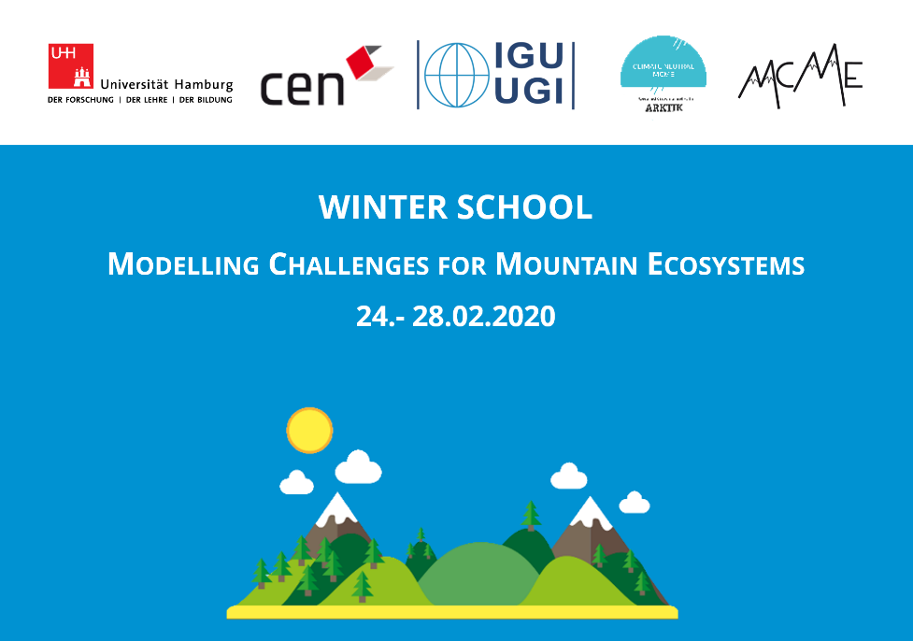

Based on heterogeneous and often topo-graphically complex terrain, high altitude ecosystems are characterised by distinct vertical climatic gradients and respective altitudinal vegetation zonations. Compared to other high mountains of the world, such as the Alps or the Rocky Mountains, the Himalayas are often underrepresented in scientific modelling literature.
Modelling studies in remote mountainous regions such as the Himalayas face numerous challenges: such as limited data availability due to difficult accessibility of the terrain, poor data basis with unknown magnitude of uncertainties and limited number of reference studies for comparison.
For the second time Maria Bobrowski, Niels Schwab and Johannes Weidinger invited international and national PhD students interested in modelling methods to answer current questions of high mountain research. The Winter School “Modelling Challenges for Mountain Ecosystem” (MCME) covered two main topics: statistical modelling of climate parameters and modelling the ecological niche of a treeline species in the Himalayan mountains.
20 students from 7 nations attended the Winter School taking place from February 24. - 28. 2020 at the Institute of Geography, University of Hamburg, Hamburg, Germany. There was a lively exchange of knowledge about the challenges of exploring high mountain areas, as well as international networking of junior scientists with a climatological and ecological background. The Winter School was funded by the Institute of Geography, University of Hamburg, the Center for Earth System Research and Sustainability (CEN) and the IGU Commission on Biogeography and Biodiversity.
The keynote lecture by Prof. Dr. Jürgen Böhner (chair physical geography, University of Hamburg), a leading expert of climatology, mountain geography and researcher in the Himalayan mountains for over 30 years, was the prelude for an exciting, interesting and instructive workshop week. In the second keynote lecture Prof. Dr. Udo Schickhoff (University of Hamburg), a leading expert in alpine treeline research for over 30 years, conveyed the underlying factors of treeline sites and the current state of research of high mountain research.
The programme of the Winter School was divided into short, introductionary lectures (“hands-off”) and current research-orientated practicals (“hands-on”).
We addressed potential model pitfalls, discussed solutions and provided example data from the Himalayas. All models were created with freely available remote sensing data (MODIS) and climate data (Chelsa), using the open-source software R.
Besides the provided example data, all participants were encouraged to prepare and work with their own data. During the Winter School, data and problems brought in by participants were discussed and analysed. The last day of the workshop was designated as a “kick-off”-day for the participants to work on their own data.
Currently the preparation of MCME 2021 are in full progress and the call will be launched in September.
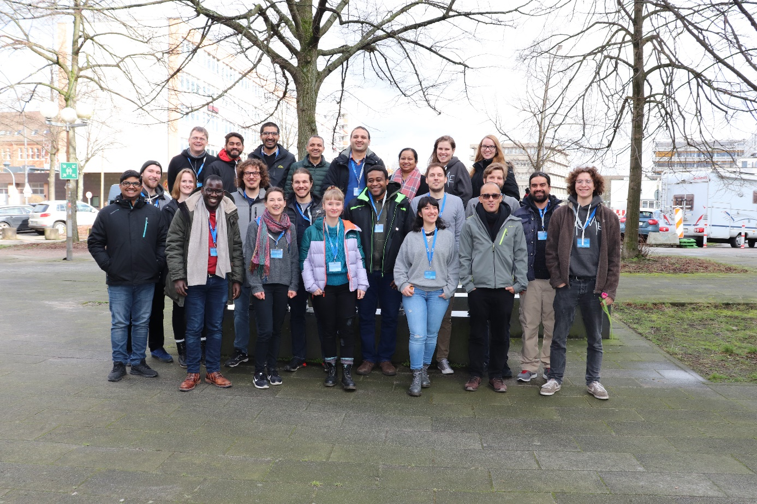
Participants, organizers and student staff of the Winter School “Modelling Challenges for Mountain Ecosystems” (MCME) 2020 at the Institute of Geography at the University of Hamburg, Hamburg, Germany.

